문제해결기법(13967005)

202135592 한웅재

소프트웨어

제출일: 2021. 9. 24

Chapter 12 Programming Exercises

12.2 #4

#define _CRT_SECURE_NO_WARNINGS// or scanf_s

#include <stdio.h>

#include <math.h>

#include <stdlib.h>

#include <string.h>

#include <time.h>

#include <ctype.h>

struct CAR {

int car_num, miles_driven, gallons_used;

}car[5] = {

{25,1450,62},

{36,3240,136},

{44,1792,76},

{52,2360,105},

{68,2114,67}

};

int main() {

double sum=0;

printf("-----report-----\n");

for (int i = 0; i < 5; i++) {

printf("CAR NUM: %d MILES PER GALLON: %f\n", car[i].car_num,(double)car[i].miles_driven / (double)car[i].gallons_used);

sum += (double)car[i].miles_driven / (double)car[i].gallons_used;

}

printf("Average miles per gallon achieved by five cars : %f", sum / 5.0);

return 0;

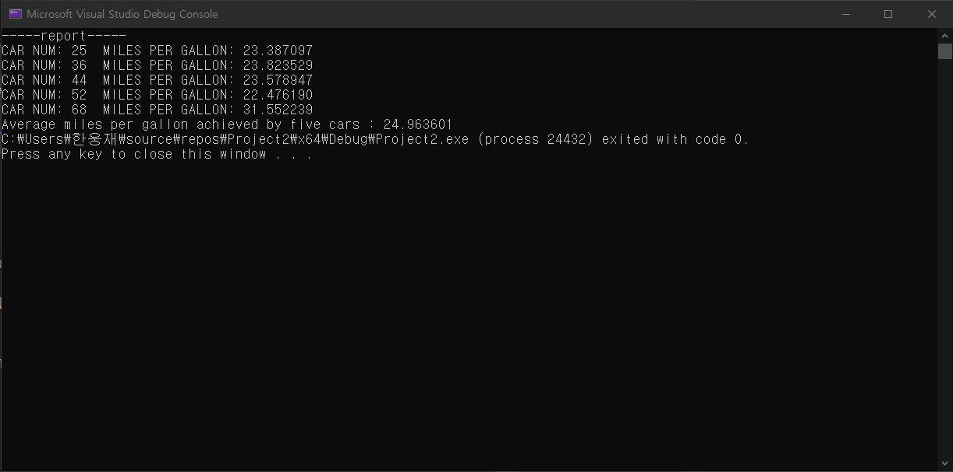

12.3 #1

#define _CRT_SECURE_NO_WARNINGS// or scanf_s

#include <stdio.h>

#include <math.h>

#include <stdlib.h>

#include <string.h>

#include <time.h>

#include <ctype.h>

int Days(struct Date dat);

struct Date {

int month;

int day;

int year;

};

int main() {

struct Date date, differnce_date;

printf("-----test_sets-----\n");

for (int i = 0; i < 5; i++) {

date.month = 1 + i;

date.day = 10 + i;

date.year = 2000 + 10 * i;

differnce_date.day = Days(date);

printf("test num : %d date : %d/%d/%d number of days : %d\n", i+1, date.month, date.day, date.year, differnce_date.day);

}

printf("--------------------\n");

return 0;

}

int Days(struct Date dat) {

dat.day = dat.day - 1 + (dat.month - 1) * 30 + (dat.year - 2000) * 360;

return dat.day;

12.3 #3

#define _CRT_SECURE_NO_WARNINGS// or scanf_s

#include <stdio.h>

#include <math.h>

#include <stdlib.h>

#include <string.h>

#include <time.h>

#include <ctype.h>

void Days(struct Date dat[]);

struct Date {

int month;

int day;

int year;

}date[5] = {

{1,1,2000},

{4,25,2002},

{11,30,2007},

{10,7,2020},

{9,24,2021}

};

struct Date differnce_date;

int main() {

printf("-----test_sets-----\n");

for (int i = 0; i < 5; i++) {

Days(date+i);

printf("test num : %d date : %d/%d/%d number of days : %d\n", i+1, date[i].month, date[i].day, date[i].year, differnce_date.day);

}

printf("--------------------\n");

return 0;

}

void Days(struct Date dat[]) {

differnce_date.day = dat->day - 1 + (dat->month - 1) * 30 + (dat->year - 2000) * 360;

}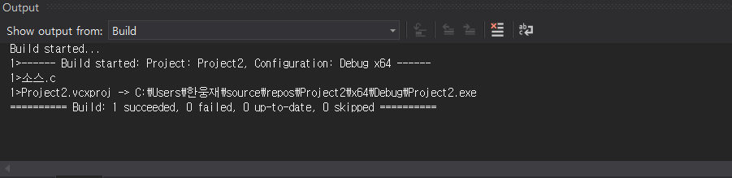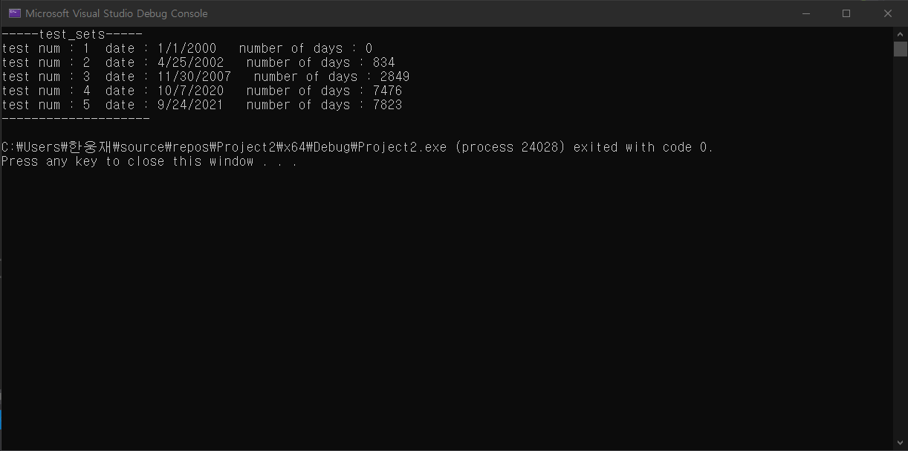

12.3 #4

#define _CRT_SECURE_NO_WARNINGS// or scanf_s

#include <stdio.h>

#include <math.h>

#include <stdlib.h>

#include <string.h>

#include <time.h>

#include <ctype.h>

struct Date recent(struct Date d1[], struct Date d2[]);

struct Date {

int month;

int day;

int year;

}dat1[5] = { {10,4,2001},{4,25,2002},{4,7,2010},{7,5,2021},{5,7,2015} }, dat2[5] = { {12,30,2001},{2,4,2000},{1,1,2009},{6,14,2014},{5,7,2015} }, dat3[5];

int main() {

printf("-----test_sets-----\n");

for (int i = 0; i < 5; i++) {

dat3[i]=recent(dat1+i,dat2+i);

printf("Test Num : %d Date(1) : %d/%d/%d Date(2) : %d/%d/%d -->> THE LATER DATE : %d/%d/%d\n",i+1, dat1[i].month,dat1[i].day,dat1[i].year, dat2[i].month,dat2[i].day, dat2[i].year, dat3[i].month, dat3[i].day, dat3[i].year);

}

return 0;

}

struct Date recent(struct Date d1[], struct Date d2[]) {

if (d1->day + d1->month * 30 + d1->year * 360 > d2->day + d2->month * 30 + d2->year * 360) {

return *d1;

}

else

return *d2;

}

